Name: Aarya Thapa
Q1. What is the purpose of the main() function in a C program? Explain its significance.
Ans: The main() function is the entry point for a C program. The execution of the program starts from the
main() function. Without the main() function, it is impossible to execute a C program. The main() function
regulates the entire execution of the program by invoking other functions and executing statements. The main()
function can return an integer value, which is often 0, to the operating system to show that the program has
executed successfully.

Q2. Explain the difference between a variable declaration and a variable initialization in C.
Ans: In C programming, declaring a variable is an instruction to the compiler regarding the name and type of
variable to be used, so memory can be allocated for it. At this point, no value is assigned to the variable, and it
is said to have a garbage value. Example: int x
Variable initialization is an assignment of a value to a variable during declaration. This is done to ensure that the
variable is initialized with a value before it is used in the program. Example: int x = 10

Q3. Write a C program to display a personalized greeting message. (Should contain 'hello' or 'welcome' in the

message)

#include <stdio.h>

int main() {
char name[50];

printf("Enter your name: ");
scanf("%s", name);

printf("Hello, %s! Welcome to the C programming world.\n", name);

return 0;
}

Result:
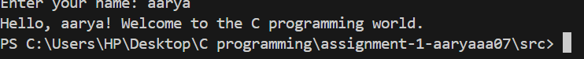

Q4. What are the different data types available in C? Provide examples of each data type.
Ans: The different data types available in C are given below:
a. Basic (Primary) Data Types:
• int: Stores whole numbers (positive or negative).
Example: int age=20;
• float: Stores decimal (floating-point) numbers with single precision.
Example: float temperature=37.5;
• double: Stores decimal numbers with double precision.
Example: double salary = 45678.75
• char: Stores a single character.
Example: char grade = 'A';

Q5. Explain the concept of type conversions in C. Provide examples of implicit and explicit type conversions.
Ans: Type conversion in C refers to the process of converting a value from one data type to another. This
is necessary because C programs often perform operations on variables of different data types, and the compiler
must ensure compatibility between them. Type conversions in C are mainly classified into implicit and explicit
type conversion.
Implicit Type Conversion: This conversion is done automatically by the compiler when different data types are
used in an expression. Smaller data types are converted into larger ones to avoid data loss.
Example:
int a = 10;

float b = 5.5;
float result = a + b;
Explicit Type Conversion: This conversion is done manually by the programmer using a casting operator.
Example:
int a = 5, b = 2;
float result = (float)a / b;

Q6. Write a C program to calculate the area of a rectangle. Prompt the user to enter the length and width, and
display the result.
#include <stdio.h>

int main() {
float length, width, area;

printf("Enter the length of the rectangle: ");
scanf("%f", &length);

printf("Enter the width of the rectangle: ");
scanf("%f", &width);

area = length * width;

printf("The area of the rectangle is: %.2f\n", area);

return 0;
}
Results: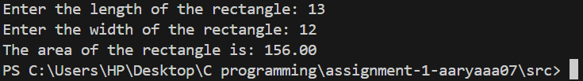

Q7. What is the role of the scanf() function in C? Provide an example of its usage.
Ans: The scanf() function in C allows you to read input from the user during program execution. It brings in
formatted input from the standard input (keyboard) and puts the values into the variables you have specified.
This function is declared in stdio.h.

Example:
#include <stdio.h>

int main() {
int age;
float marks;
printf("Enter your age and marks: ");
scanf("%d %f", &age, &marks);
printf("Age: %d\nMarks: %.2f", age, marks);
return 0;
}
Q8. Write a C program to convert temperature from Celsius to Fahrenheit. Prompt the user for a temperature in
Celsius and display the equivalent temperature in Fahrenheit. (Formula: fahrenheit = (celsius * 9 / 5) + 32)
int main() {
float celsius, fahrenheit;

printf("Enter temperature in Celsius: ");
scanf("%f", &celsius);

fahrenheit = (celsius * 9 / 5) + 32;

printf("Temperature in Fahrenheit: %.2f\n", fahrenheit);

return 0;
}
Result:
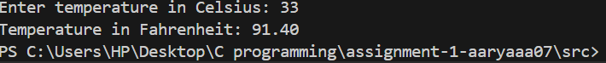

Q9. Input a number representing days and print the equivalent number of weeks and days. (Example: 10 days =
1 week and 3 days)
#include <stdio.h>

int main() {
int number;
int week,remaining_days;

printf("Enter a number:");
scanf("%d",&number);
week=number/7;
remaining_days=number%7;
printf("%d week %d days",week,remaining_days);
return 0;
}

Result:
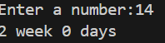

Q10. Write a C program to swap the values of two variables using a temporary variable.
int main() {
int a, b, temp;

printf("Enter first number: ");
scanf("%d", &a);

printf("Enter second number: ");
scanf("%d", &b);

temp = a;
a = b;
b = temp;

printf("After swapping:\n");
printf("First number = %d\n", a);
printf("Second number = %d\n", b);

return 0;
}

Result:
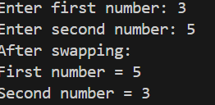

Q11. Write a C expression that performs the following operations in a single line: increment a variable by 1,
multiply it by 3, and subtract 10
#include <stdio.h>

int main() {
int num;
int result;

printf("enter a variable:");
scanf("%d",&num);

result=(num++,num*3-10);
printf("The result is %d\n",result);
return 0;

}

Result:
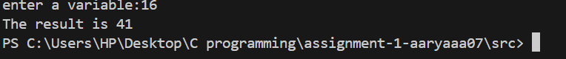

Q12. Given three variables a, b, and c, write an expression that checks if a is greater than b and c is not equal to
0.

#include <stdio.h>
int main(){
int a,b,c;
int result;

printf("enter three variables:");
scanf("%d %d %d",&a,&b,&c);

result=(a>b) && (c!= 0);
printf("the result is %d",result);

return 0;

}

Result:
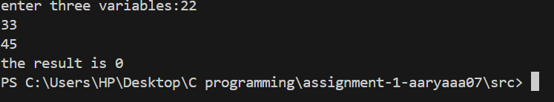

Q13. Write a C expression that evaluates whether a number is divisible by both 2 and 3 (without using the
modulus operator).
#include <stdio.h>

int main(){
int n;
int result;
printf("Enter a number:");
scanf("%d",&n);
result=(n/2*2==n)&&(n/3*3==n);
printf("The result is %d\n",result);
return 0;
}

Result:
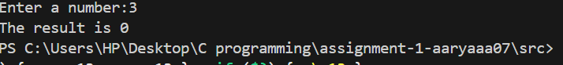

Q14. Create an expression that swaps the values of two variables x and y without using a temporary variable.
#include <stdio.h>
#include <stdio.h>

int main(){
int x,y;
printf("Enter two variables:");
scanf("%d %d",&x,&y);
x=x+y;

y=x-y;

x=x-y;
printf("The value of x after swapping is %d and y is %d\n",x,y);
return 0;
}

Result:
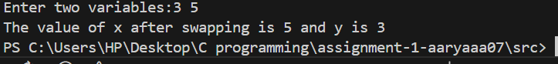

Q15. Write an expression that checks if a number is both positive and even.
#include <stdio.h>
int main(){

int n;
int result;
printf("Enter a number:");
scanf("%d",&n);
result=(n>0)&&(n%2==0);
printf("The result is %d\n",result);
return 0;
}

Result:
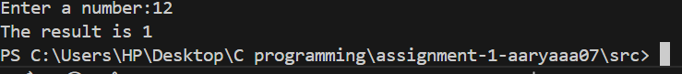

Q16. Given two variables x and y, write an expression that calculates the average of their values.
#include <stdio.h>

int main() {
float x, y, average;

printf("Enter the first number (x): ");
scanf("%f", &x);

printf("Enter the second number (y): ");
scanf("%f", &y);

average = (x + y) / 2;

printf("The average of %.2f and %.2f is %.2f\n", x, y, average);

return 0;
}
Result:
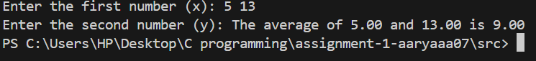

Q17. Create an expression that checks if a given character is an uppercase letter.
#include <stdio.h>

int main() {
char ch;

printf("Enter a character: ");
scanf("%c", &ch);

if (ch >= 'A' && ch <= 'Z') {
printf("%c is an uppercase letter.\n", ch);
} else {
printf("%c is NOT an uppercase letter.\n", ch);
}

return 0;
}

Result:
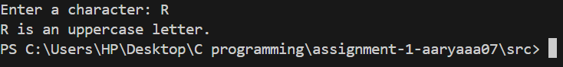
Q18. Write a C expression that calculates the sum of the squares of three different numbers.
#include <stdio.h>

int main() {
int a, b, c, sum_of_squares;

printf("Enter first number: ");
scanf("%d", &a);

printf("Enter second number: ");
scanf("%d", &b);

printf("Enter third number: ");
scanf("%d", &c);

sum_of_squares = (a * a) + (b * b) + (c * c);

printf("The sum of the squares of %d, %d, and %d is %d\n", a, b, c, sum_of_squares);

return 0;
}

Result:
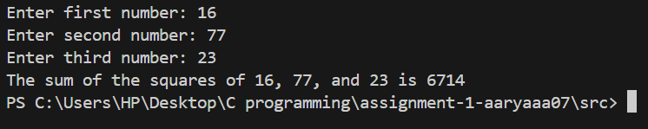

Q19. Given three variables a, b, and c, write an expression that checks if a is equal to b and b is not equal to c.
#include <stdio.h>

int main() {
int a, b, c;

printf("Enter value of a: ");
scanf("%d", &a);

printf("Enter value of b: ");
scanf("%d", &b);

printf("Enter value of c: ");
scanf("%d", &c);

if (a == b && b != c) {
printf("Condition satisfied: a is equal to b and b is not equal to c.\n");
} else {
printf("Condition NOT satisfied.\n");
}

return 0;
}

Result:
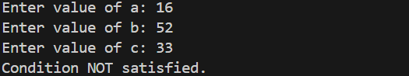

Q20. Write an expression that checks if a number is a multiple of either 3 or 5.

#include <stdio.h>

int main() {
int n;

printf("Enter a number: ");
scanf("%d", &n);

if (n % 3 == 0 || n % 5 == 0) {
printf("%d is a multiple of 3 or 5.\n", n);
} else {
printf("%d is NOT a multiple of 3 or 5.\n", n);
}

return 0;
}

Result:
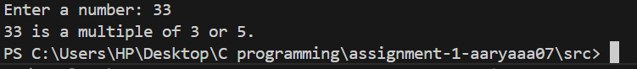
Q21. Create an expression that swaps the values of three variables x, y, and z in a cyclic order (i.e., x becomes
y, y becomes z, and z becomes x).
#include <stdio.h>

int main() {
int x, y, z, temp;

printf("Enter value of x: ");
scanf("%d", &x);

printf("Enter value of y: ");
scanf("%d", &y);

printf("Enter value of z: ");
scanf("%d", &z);

temp = x;
x = y;
y = z;
z = temp;

printf("After cyclic swap:\n");
printf("x = %d\n", x);
printf("y = %d\n", y);
printf("z = %d\n", z);

return 0;
}

Result:
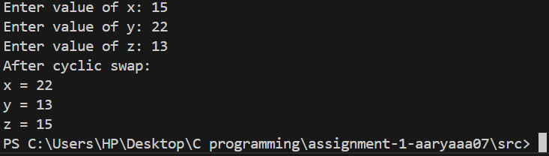

Q22. Write a C expression that calculates the square root of the sum of two numbers, rounded to the nearest
integer.
#include <stdio.h>
#include <math.h>

int main (){

int x,y;
int sum;
printf(" Enter two numbers:");
scanf("%d %d", &x, &y);

sum= round(sqrt(x)+sqrt(y));

printf("The sum is %d\n", sum);

return 0;

}
Result:
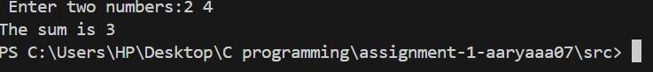
Q23. Given a variable num, write an expression that checks if it is a power of 2.
#include <stdio.h>

int main(){
int num;
int result;

printf("enter a number");
scanf("%d",&num);
result=!(num&(num-1));
printf("the result is %d\n",result);
return 0;

}

Result:
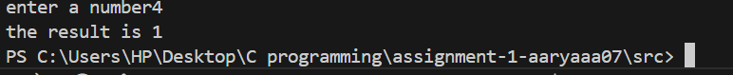

Q24. Create an expression that checks if a given number is a perfect square.
#include <stdio.h>

#include <math.h>

int main () {

int num;
int result;

printf("Enter a number:");
scanf("%d", &num);

result= (sqrt(num)*sqrt(num)==num);

printf("the result is %d\n", result);

return 0;

}

Result:
